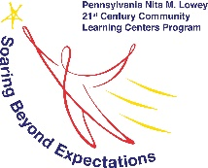
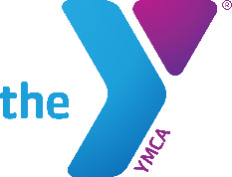
YMCA of Bucks County l Bristol Township School District
NITA M. LOWEY 21st CENTURY COMMUNITY LEARNING CENTERS
Providing enrichment opportunities during non-school hours.
Funding provided by the Pennsylvania Department of Education.

September 30, 2021

Dear FDR Parent/Guardians,

We are pleased to announce that we will be offering the Success Zone Program again this year at FDR Middle School for students in 6th through 8th grades. The program will run Monday through Thursday from dismissal until 5:00 pm (excluding days scheduled for early dismissal), beginning Monday, October 11, 2021.
The Success Zone will provide homework help, academic enrichment activities, STEM (Science, Technology, Engineering, Mathematics) education, arts, executive functions and social skills, literacy, nutrition and wellness programs, and character education programs. Please note that this is not a homework club, as our funding requires us to provide multiple activities each day and throughout the year. While we expect that your child will complete all or the majority of their homework on most days, there is no guarantee.
The Success Zone Program is funded through a grant from Pennsylvania Department of Education, and there is no cost for students to participate. Students are provided a daily nutritious snack. Please note that students may take the district late activity bus at the 5:00 pm dismissal, or you may pick your child up in front of the middle school no later than 5:00 pm.
FDR registration link: https://bit.ly/fdr21cclc
We are looking forward to an exciting new program year, and hope that you will consider joining us. If you would like additional information about 21st Century Programs, please feel free to contact Kim Pattley using the contact information below.

YMCA OF BUCKS COUNTY l Fairless Hills
2500 Lower State Road, Doylestown, PA 18901 l 215.348.8131 l ymcabucks.org

NITA M. LOWEY 21st CENTURY COMMUNITY LEARNING CENTERS
Kimberly Pattley, Project Director l 215.280.0574 l KPattley@YMCABucks.org
Kate Barszczewski, Project Director l 215.510.7686 l KBarszczewski@YMCABucks.org

